ENTITY-RELATIONSHIP MODEL

Practice Exercises
Answer each question in the space provided. Refer back to your notes on entities, attributes, keys, and relationship types as needed.

Show your reasoning, not just a final label — several questions ask you to explain your rationale.

Question 1
A university maintains information about students. Each student has a student ID, name, date of birth, email address, and major. The university stores thousands of student records.
a. Identify the entity
b. Provide three examples of entity instances
c. Identify five attributes of the entity
d. Explain the difference between an entity and an entity instance
Question 2
A customer database stores the following attributes. Classify each attribute as Atomic or Composite, and Stored or Derived, and explain your rationale.
Attribute | Classification (Atomic/Composite, Stored/Derived) | Rationale
CustomerID
CustomerName
CustomerAddress
DateofBirth
Age
AccountBalance
PhoneNumber

Question 3
Analyze the following relationships and identify whether each relationship is One-to-One, One-to-Many, or Many-to-Many.
a. A customer can place many orders
b. A student can enroll in many courses
c. Each employee has one company parking permit
d. Each department has many employees
Question 4
A university bookstore tracks textbooks, authors, publishers, and sales transactions.
a. Identify four possible entities
b. Explain why each item qualifies as an entity
c. Identify one possible instance of each entity
Question 5
A medical clinic stores information about patients. Determine whether each item is an entity or an attribute and explain your rationale.
a. Patient
b. PatientName
c. InsuranceCompany
d. Appointment
e. PhoneNumber
f. Physician
Question 6
Analyze the following relationships and identify the relationship type, the parent entity, the child entity, and explain whether an associative entity is required.
a. A person has one passport. A passport belongs to one person.
Relationship Type
Parent Entity
Child Entity
Associative Entity Required? (Y/N)
Explanation:
b. A department employs many employees. Each employee works for one department.
Relationship Type
Parent Entity
Child Entity
Associative Entity Required? (Y/N)
Explanation:
c. A student can enroll in many courses. Each course can contain many students.
Relationship Type
Parent Entity
Child Entity
Associative Entity Required? (Y/N)
Explanation:
d. A vehicle has one assigned license plate. A license plate belongs to one vehicle.
Relationship Type
Parent Entity
Child Entity
Associative Entity Required? (Y/N)
Explanation:
Question 7
A company stores employee information:
EmployeeNumber
SocialInsuranceNumber
EmployeeName
HireDate
a. Select the best primary key
b. Explain why the other attributes are not ideal primary keys
Question 8
Analyze the following business rules and identify whether each relationship is One-to-One, One-to-Many, or Many-to-Many.
a. Each vehicle has one VIN number
b. A customer can submit multiple support tickets
c. A movie can have many actors, and an actor can appear in many movies
Question 9
A music streaming service stores artists and songs with the following business rules: an artist can create many songs, a song can have many artists, and each song must track the artist's contribution.
a. Identify the many-to-many relationship
b. Create an associative entity to resolve the relationship
c. Identify the primary key of the associative entity
d. Identify all foreign keys
Question 10
A restaurant tracks customer reservations. A reservation may use one or more dining tables, and a dining table may be used for many reservations over time. Given the following ERD, answer the corresponding questions:
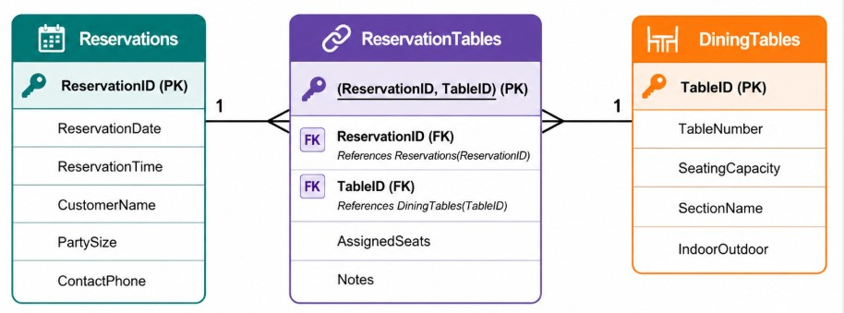
a. Identify the associative entity
b. Explain why ReservationTables requires a composite primary key
c. Identify the relationships
d. Describe the cardinality between Reservations and DiningTables
e. Explain how this design prevents duplicate reservations

